**SQL**

DB

**SQL**

RD: Generating a database

Assignment

Contents

Relational Databases Assignment Generating a database to map the 2021 F1 season. 2

Introduction: 2

Specification: 2

Notes: 3

Task List: 3

|  |  |
| --- | --- |
| Course:  Stage/Year:  Module:  Semester:  Assignment Number:  Date of Issue:  Assignment Deadline:  Assignment Submission:  Assignment Weighting:  Assignment Title: | HDC  1  Relational Databases  Semester 2  1  TBD  TBD  Upload the completed assignment in .pdf format to Moodle  15%  Generating a database |

# Relational Databases Assignment Generating a database to map the 2021 F1 season.

## Introduction:

The goal of this assignment is to combine all of the skills you have learned in the practical worksheets to generate a database to map information about the 2021 Formula 1 season. You will have three weeks to do this assignment because this database will be significantly larger than those you have encountered so far. Here you will need to map, drivers, teams, tracks, results within the database. You will be required to construct it and insert information into it. All information you will require can be found here.

<http://www.formula1.com/>

<https://www.formula1.com/en/racing/2021.html>

Due to the sheer scale of data involved you will only be required to map information about 4 drivers in particular: Lewis Hamilton & Valtteri Bottas and Max Verstappen & Sergio Perez for Mercedes and Red Bull respectively. The spec you need is listed below. NOTE: you are required to make a MySQL database for this assignment.

## Specification:

In the 2021 F1 season that ended on the 12th of December there were 10 teams competing in 22 races in total.

Each team was required to enter two cars in each and every race of the season.

Each car was driven by one driver in a race.

Drivers were required to set a grid in qualifying on the Saturday for the Sunday, with the fastest driver first and the slowest last.

After the race on the Sunday points would be awarded to both drivers and teams based on drivers finishing in the top 10 places.

Note that sometimes drivers would retire from races or not start. In these cases, you are permitted to use the value of 21 to represent these cases.

This process would be done for 22 races with the first starting in Bahrain and the last finishing in Abu Dhabi. Your database will be required to map the results for both qualifying and the race for each individual race in the calendar to answer questions about the overall season.

## Notes:

You will be required to submit a pdf and your database inside an archive and submit to the Moodle. However, this should be easily doable within the lab sessions that you have. You will be required to submit a MySQL dump along with a PDF containing all your diagrams and the normalisation process in your database along with all of your answers

**Most importantly is that you must realise that there are multiple ways of generating such a database. There is no single one answer to this assignment. You have full free reign over the structure of the database. I will not give advice on what primary keys, foreign keys, table divisions, or information you will need in your database. You may ask me about the specification, but it is you who must decide how to construct your database.**

Depending on how you design your database you may make it easy or hard to insert information and run your queries.

## Task List:

1. Generate an ER diagram of this database that maps all of the necessary concepts required for this database. You are required to map all of the relationships between all entities. (20%)

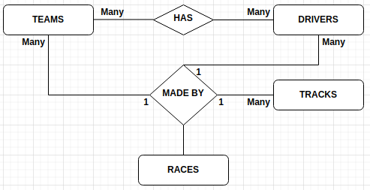

1. Normalise your database and explain why it is in third normal form. (20%)

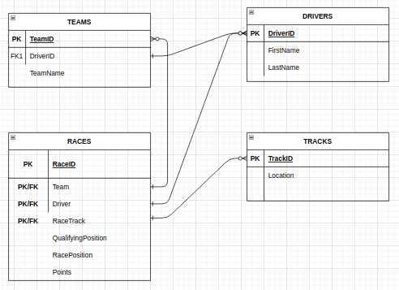

1. insert all of the information for the four drivers and two teams listed above for 22 qualifying and races. You are not required to show all of your insert statements here. (10%)

INSERT INTO drivers VALUES ("44", "Lewis", "Hamilton"), ("5", "Sergio", "Perez"), ("33", "Max", "Verstappen"), ("77", "Valtteri", "Bottas");

INSERT INTO teams(TeamName,TeamDrivers) VALUES ("Mercedes", "44"), ("Mercedes", "77"), ("RED BULL", "5"), ("RED BULL", "33");

INSERT INTO tracks(Location) VALUES("Bahrain"), ("Italy"), ("Portugal"), ("Spain"), ("Monaco"), ("Azerbaijan"), ("France"), ("Styria"), ("Austria"), ("Great Britain"), ("Hungary"), ("Belgium"), ("Netherlands"), ("Italy"), ("Russia"), ("Turkey"), ("United States"), ("Mexico"), ("Brazil"), ("Qatar"), ("Saudi Arabia"), ("Abu Dhabi");

INSERT INTO races VALUES ("Round01", "1", "44", "1", "2", "1", "25"),

("Round01", "1", "77", "2", "3", "3", "16"),

("Round01", "1", "33", "3", "1", "2", "18"),

("Round01", "1", "5", "4", "11", "5", "10"),

("Round02", "2", "44", "1", "1", "2", "19"),

("Round02", "2", "77", "2", "8", "21", "0"),

("Round02", "2", "33", "3", "3", "1", "25"),

("Round02", "2", "5", "4", "2", "11", "0"),

("Round03", "3", "44", "1", "2", "1", "25"),

("Round03", "3", "77", "2", "1", "3", "16"),

("Round03", "3", "33", "3", "3", "1", "25"),

("Round03", "3", "5", "4", "4", "4", "12"),

("Round04", "4", "44", "1", "1", "1", "25"),

("Round04", "4", "77", "2", "3", "3", "15"),

("Round04", "4", "33", "3", "2", "2", "19"),

("Round04", "4", "5", "4", "8", "5", "10"),

1. write queries and show your results for the following (50%, 5% for each one.)
2. How many times did each driver appear on the podium (top three places)?

|  |
| --- |
|  |

1. How many points did each driver score in the season?

|  |
| --- |
|  |

1. How many points did each team score in the season?

|  |
| --- |
|  |

1. What was the average finishing position of each driver in the season?

|  |
| --- |
|  |

1. How many pole positions did each driver achieve?

|  |
| --- |
|  |

1. How many pole positions did each team get?

|  |
| --- |
|  |

1. How many race wins did each driver get?

|  |
| --- |
|  |

1. How many race wins did each team get?

|  |
| --- |
|  |

1. The names of the races won by Lewis Hamilton & Valtteri Bottas

|  |
| --- |
|  |

1. The names of the races where Max Verstappen & Sergio Perez got pole position.

|  |
| --- |
|  |